FinAID, A Financial Advisor Application using AI

# Ashish Shah, Pratik Raj, Pushpam Kumar, Supriya P, Asha H V

***Abstract: The need for skilled financial advisors is more than ever in the current scenario when there are in-numerous money- making strategies and at the same time, the global economy might be on the verge of collapse. Also there is a pure lack of good financial advisors and even if you find one, you will end up paying a hefty amount. The current proposed application fulfils the above-stated demand in a cost-effective and reliable way. The proposed system automates the job of a financial advisor using Artificial Intelligence. It provides the user with a simple and easy to use interface where every individual will have their own account handled by Google’s firebase platform. The application uses 'Plaid' API which allows app to send a request to the corresponding bank server and fetch the account details of an individual. Logged in user is shown a very comprehensive representation of their account details which also includes category-wise expenditure, their investment, and the savings. One of the unique parts of this project is a Chatbot which is ever ready to answer the queries of the user related to their accounts and finance. Dialogflow will help in the functionality of Chatbot incorporating Google's machine learning expertise. The proposed application will help provide every needy individual a very reliable, easy to use, and cost-efficient solution to their problem of having a personal financial advisor.***

***INDEX TERMS: Artificial Intelligence, Firebase, Plaid API, Dialogflow, Chatbot.***

## INTRODUCTION

Keeping track of financial expenses is not an easy task for a regular individual. Accounting of your income, expenditure, loans, taxes, and investments is a pretty hectic job. Financial planning is needed for a sustainable present and future.

Financial consultants counsel clients about managing expenses in accordance with their income and ways to invest in different markets to boost income. For this, the consultants have to be on their toes every moment as the markets change in a blink of an eye. They need to follow the changes and advice their clients about the best possible investments and for this they charge a hefty sum of money for their services. With advancements in technology, even financial sector has become less human dependent. Personal mobile applications powered by machine learning algorithms started to flourish in the market. But they weren’t too reliable due to their inaccuracies in prediction and suggestions. However, the involvement of Artificial Intelligence (AI) into the sector completely changed the game. AI with the help of Neural Networks can do much accurate and faster predictions than any individual.

**Revised Manuscript Received on May 21, 2020.**

**Ashish Shah,** Students Dept of CSE, Nitte Meenakshi Institute of Technology, Bangalore

**Pratik Raj,** Students Dept of CSE, Nitte Meenakshi Institute of Technology, Bangalore

**Pushpam Kumar,** Students Dept of CSE, Nitte Meenakshi Institute of Technology, Bangalore

**Supriya P,** Assistant Professor Dept of CSE, Nitte Meenakshi Institute of Technology, Bangalore

**Asha H V,** Assistant Professor Dept of CSE, Nitte Meenakshi Institute of Technology, Bangalore

Now the use of AI for personal financial advisor is gaining its popularity and more accurate the algorithms gets, the sector will become more profitable. Financial advisor applications fetch user transaction data from their bank accounts; can categorize various transactions done by the user under the section of income, loans, expenses, taxes etc. It can then give information about the same to the user. Based on advanced machine learning algorithms, some applications may also predict various stock prices and advice a good stock to invest in. In this paper, section two discusses about the diverse surviving systems and the methods implemented by various research scholars. The third section of the paper briefly explains the problem, the solution proposed with the architectural design, the methodologies used for implementation. The experimental results obtained from the implemented system are presented in section four. Fifth and the last section provide conclusion along with future scope.

## RELATED WORK

SmartAsset [1] provides information on financial advisor. Every individual seeks financial advice to make wise investments which will help him post retirement. But seeking the help of financial advisors brings a heavy toll on the individual’s expenses. Today most Financial Advisors charge a fee of about $1000 to $3000 for complete financial plan or 1% to 2% value of the assets under management. Most challenging task is to figure out whether the person is getting a fair advice for the fees charged. Christian and et. al., [2] elaborates on the financial advisory services which can be provided through mobile channels. This paper elicits the various design requirements for availing advisory services through mobile apps. Mobile Financial advisory services are gaining huge demand with customers of banks are becoming more demanding and are looking out for new services which can be provided by banks[3]. [3] and [4] elaborates on various segments of finance where customers are involved, like corporate, retail and private customers of banks who demand for new services. They also emphasize on importance of designing new services for banking sector and individuals making huge investment. According to [5], the proposed system creates an agent base on natural language processing, which provide necessary information about the stocks the user intend to buy. It concentrates on maximizing the user portfolio. It also discusses on delegating task to agent, and boosting their returns through collaboration with other agents.

1. Explains the task of deriving assertions from specified natural language specifications. It mainly concentrated on recognizing and appreciating a wide variety of linguistic variants, allowing for free speech by the author of natural language specifications.

Chatbots [5] acts as an interface between the application and users. The trend for chatbots has increased with more companies providing frameworks with variety of features. The text elaborates on the technologies followed with respect to development of chatbots and provides hands on experience in the use of conversational interface chatbots [6]

1. [8]. Chatbot works on the idea of accepting a message from an advice seeker which is analysed using NLP techniques. Working of chatbots includes two phases: (i) Classification of Intent: Dialogflow chatbot [9] requires the developer to provide sentences for training. The sentences are like "Can you check for savings balance?” and "What is the balance in the savings account?" can be used to train the intent for checking the balance of savings account. In this phase the meaning of the sentences are captured and are categorised into intents. Depending on the classified intents, response for the query is generated. (ii) Slot Filling: involves extracting text [10] which can belong to a particular intent. The extracted text are the parameters as considered by Dialogflow and the intents described for the application are associated with parameters which is used by chatbot to respond for the queries. In the above example 'balance' can be a parameter, which is used by chatbot to answer the query by retrieving the balance from the bank statement.

Rajat, Ahuja and et al [11], elaborates on using opinion by public along with sentiment analysis of stock market to determine the relations between individual moods and stick market. It elicits on the Chatbot training and for further developments, to do sentiment analysis on twitter data and give its users top trending stocks to invest in. [12] This paper aims on usage of a distributed, large scale, agent system to maximize the usage of computers for dealing with problems in the area of finance. The design mainly concentrates on usage of agent based system to increase the portfolio of the individual. The system delegates the task to an agent, who in turn in order to increase the returns for the user collaborates with number of other agents

Balance Careers [13] elaborates on the role of a financial advisor or financial consultant as called in the earlier days. Financial advisors counsel clients on various investment opportunities and for this he needs to be updated with the fluctuations in the stock prices and market price happening every minute. Financial advisors vary by helping an individual and also large business firms. These advisors receive payment on commission basis or few even earn salaries with additional commission on the profit made. Their annual pay may range between $36,000 for beginners to $161,401 for an experienced advisor who has established a notable client base.

## PROPOSED WORK

### Problem Description

Every individual needs to track their financial data in order to spend efficiently, increase the savings for better investment. However, experienced human advisors cost a lot. According to smart asset [1], financial advisors charge huge amount of money. The time taken by an individual to do the financial calculations takes a significant amount of time and energy. The calculations and results can be faulty

at times. All the above shortcomings can easily be overcome by using a mobile application backed by Artificial Intelligence. It will save a significant amount of money but also be more reliable than a normal human financial advisor. Moreover, it can be used by anyone having access to mobile phones and internet which involves pretty much every needy individual. It will also do all the necessary calculations in seconds and the results are comparatively more trustworthy.

### Proposed Architecture

The system architecture proposed in this paper is show in Figure 1, which includes the various phases of application like user authentication, connection with bank server, categorization of user’s transactions, pictorial representation of expenditure and Chatbot.

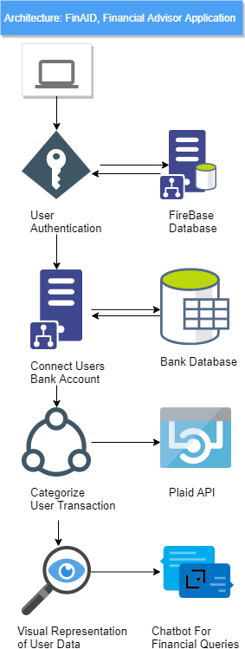

**Figure 1: Architecture of the Proposed System**

### User Authentication

The services provided by Google’s Firebase are used for User Authentication. Firebase Auth lets users authenticate using only client-side code. Email & password of the user is required to login into the app, which is stored in the Firebase real-time database in encrypted form. Additionally, user management system provides authentication platform for validating the user email and password login with the ones in the Firebase. Firebase real-time database provides the developer with an API to store application data in JSON format on the cloud and to synchronize with each client. Integration of the application with Android, IOS is also possible.

### Connect Users Bank Account

Plaid API is used to interface the application with the individual’s bank. Plaid allows developers to desegregate transactions and account data of the many important financial institutions into third-party applications. It is a REST API and therefore the response uses JSON format. The request and response are sent over HTTPS TLS v1.1+ to make sure data integrity. Plaid API provides the interface to choose a bank and then enter valid credentials. The credentials are sent to bank for authentication. Figure 2 shows the User authentication details in JSON format.

### Categorize User Transactions

After providing valid credentials, if authorized by the bank, bank sends transaction data in the JSON format which is then categorized by the Plaid CaaS (Container as a Service), based on the labels. Note that this data is not stored. Figure 3 represent the transactions details of the individual in JSON format.

### Visual Representation of User Transactions

The categorized transaction data is then visualized in the form of a Pie-chart using Any-Chart tool. Anychart is a Javascript based solution that allows developers to embed interactive charts and dashboards into standalone or mobile or web projects.

### Chatbot for Financial Queries

Chatbot [3] fetches the user details from the bank and replies to user’s queries through text messages. Dialog-flow uses the capabilities of Artificial Intelligence to answer the queries of users related to their account and top trending stocks (such as "What's my balance?", “Can I buy Facebook stocks?", etc.). Interfaces based on voice and text is used to collaborate users with their product through Dialogflow. Machine Learning capabilities and Google’s speech to text application are the major strengths of Dialogflow. Dialogflow builds interfaces based on voice and text to allow the user to interact with the product. Chatbot is one such conversational interface based on text and powered by Artificial Intelligence.

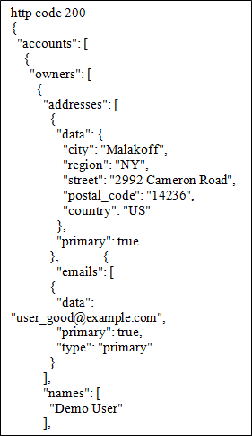

**Figure 2: User authentication Details in JSON format**

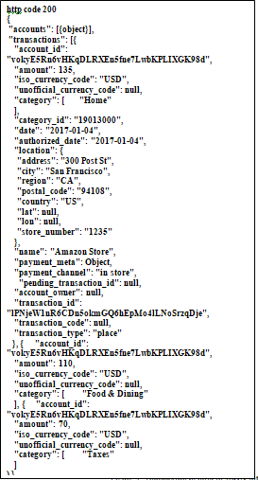

**Figure 3: Transaction details in JSON format**

### System Design

The android mobile application proposed includes a login page which requires the individual to provide user credentials to access the advisor app. The app allows the user to choose from multiple pre-listed banks. A second login page is provided for the users to provide his/her bank credentials for secure logging in to the account of the user. After secure logging, the account statement is accessed to give a pictorial representation depicting user’s financial records. Additional feature of a Chatbot fetches the user details from the bank and replies to user’s queries through text messages. Figure 4 shows the flow of user’s interaction with the application.

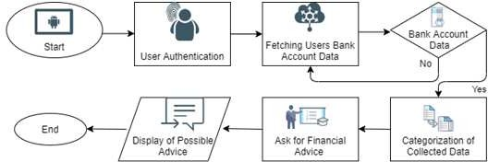

**Figure 4: System Flowchart**

## EXPERIMENTAL RESULTS

The application showing lists the banks which let the plaid API use its services is as show in Figure 5(a). Plaid API links the application with the bank server for obtaining the users transaction details and shows the balance information of the individual accessed by the Plaid API (Figure 5(b)).

Figure 5(c) shows the use of Chatbots for seeking financial advice by the bank customers.

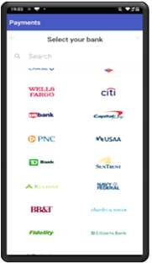

**Figure 5(a): Banks Available for Plaid API**

Graphical representation of the categories of transaction of the user is done using Anychart [15] as seen in Figure [6].

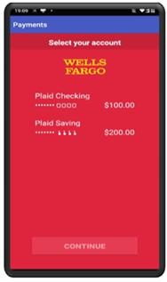

**Figure 5(b): Plaid Accessing the Balance Info**

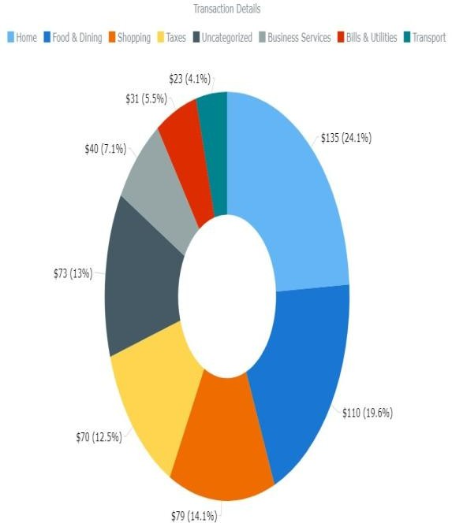

**Figure 6: Graph Constructed for expenses categorised as sectors**

## CONCLUSION AND FUTURE SCOPE

The goal of this project is to apply methods and insights from the extensive literature on financial management application to make it easy for users to manage their finances and make better financial decisions without paying hefty amount of fees to the financial advisors. It also helps them to invest their saving in a better way, track expenses and achieve financial stability. The app uses Dialog-Flow AI capabilities to reply to general user queries. However, the application still needs to be

trained to get results for advanced queries. Also, the Plaid API used in the project, supports about 9600 [14] financial institutions but it isn’t available



**Figure 5(c): ChatBot Answering Clients Queries**

in India right now. Nevertheless, considering its growth, it might be operational in India soon. In future, the app can be integrated with tensor-flow for using much more advanced algorithms like NLP to give ‘predictions’ for queries related to future financial conditions of the user. To help users to maximize their profits, this application can also take a 1% cut from the monthly budget and put it into the stocks of the major profiting companies using twitter sentiment analysis. Various Stock market prediction methods can be used to give its users, a more accurate result about investing in profitable stocks.

## REFERENCES

1. Smart Assets URL: https://smartasset.com/ financial- advisor/financial-advisor-cost
2. Ruf, Christian, et al., "Elicitation of requirements for the design of mobile financial advisory services-instantiation and validation of the requirement data model with a multi-method approach", 48th Hawaii International Conference on System Sciences,IEEE, pp 1169- 1178,2015.
3. Mowes, Till, Thomas Puschmann, and Rainer,"Service-based integration of IT-innovations in customer-bank-interaction", pp 170- 179, 2011.
4. Nussbaumer, Philipp, et al, "Designing for cost transparency in investment advisory service encounters", Business & Information Systems Engineering 4.6, pp 347-361, 2012.
5. Pandey, Vikrant, Wee-Keong Ng, and Ee-Peng Lim, "Financial advisor agent in a multi-agent financial trading system", Proceedings 11th International Workshop on Database and Expert Systems Applications, IEEE, pp 482-486, 2000.
6. Keszocze, Oliver, and Ian G. Harris, "Chatbot-based assertion generation from natural language specifications", Forum for Specification and Design Languages (FDL), IEEE, pp 1-6, 2019.
7. Shevat, Amir, “Designing bots: Creating conversational experiences",

O'Reilly Media, Inc. [Book], 2017.

1. Janarthanam, Srini, “Hands-on chatbots and conversational UI development: build chatbots and voice user interfaces with Chatfuel, Dialogflow”, Microsoft Bot Framework, Twilio, and Alexa Skills. Packt Publishing Ltd,[Book], 2017.
2. Google Dialogflow. URL: https://dialogflow.com/.
3. Tur, Gokhan, Asli Celikyilmaz, and Dilek Hakkani-Tür, "Latent semantic modeling for slot filling in conversational understanding", IEEE International Conference on Acoustics, Speech and Signal Processing, pp 8307-8311, IEEE, 2013.
4. Ahuja, Rajat, et al, "Stock market forecast using sentiment analysis", 2nd International Conference on Computing for Sustainable Global Development (INDIACom).,IEEE, pp 1008-1010, 2015.
5. V. Pandey, Wee-Keong Ng and Ee-Peng Lim, "Financial advisor agent in a multi-agent financial trading system," Proceedings 11th International Workshop on Database and Expert Systems Applications, London, UK, pp. 482-486, 2000.
6. The BalanceCareers URL: https://www.thebalancecareers

.com/financial-consultant-1286728

1. PLAID URL: https://plaid.com/
2. Anychart URL: https://[www.anychart.com](http://www.anychart.com/) /products/ any chart/docs/

**AUTHORS PROFILE**



**Ashish Shah** is currently pursuing his final year of Bachelor’s in Computer Science & Engineering at Nitte Meenakshi Inctitute of Technology, Bangalore. His areas of interest include Machine Learning and Artificial intelligence.

**Pratik Raj** is currently pursuing his final year of Bachelor’s in Computer Science & Engineering from Nitte Meenakshi Inctitute of Technology, Bangalore. His areas of interest include Machine Learning, Artificial Intelligence and Android applications Development.

**Pushpam Kumar** is currently pursuing his final year of Bachelor’s in Computer Science & Engineering from Nitte Meenakshi Inctitute of Technology, Bangalore. His areas of interest include Machine Learning and Artificial intelligence.

**Mrs. Supriya P**, is working as Assistant Professor, Department of Computer Science & Engineering, Nitte Meenakshi Institute of Technology, Bangalore. Her area of interests includes User Interface Technologies, Mobile Application Development, and Machine Learning.

**Mrs. Asha H V**, is working as Assistant Professor, Department of Computer Science & Engineering, Nitte Meenakshi Institute of Technology, Bangalore. Her area of interests includes Service Oriented Architecture and Machine Learning.